Unbounded Region
# Source: AI Source: Provided by: [Data Path: Persons Table -> ID Column: 1, Name_En Column: Motasem Essam] -> From: [ChatGPT] on [7/25/2026]
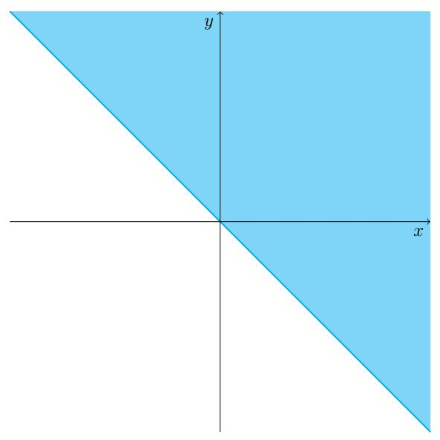
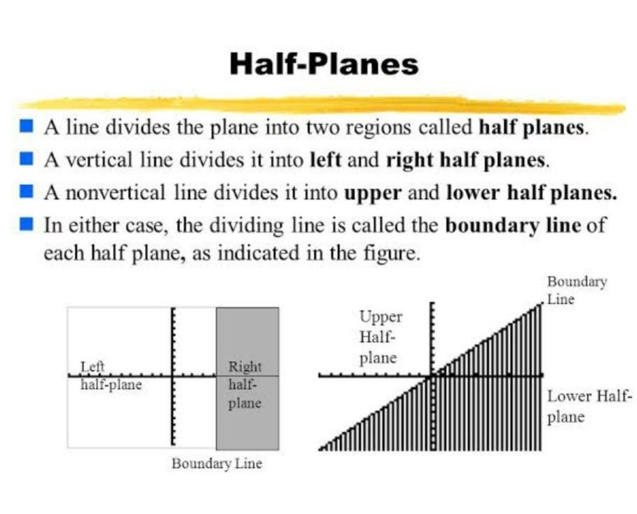
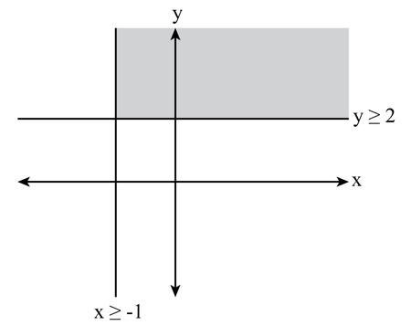
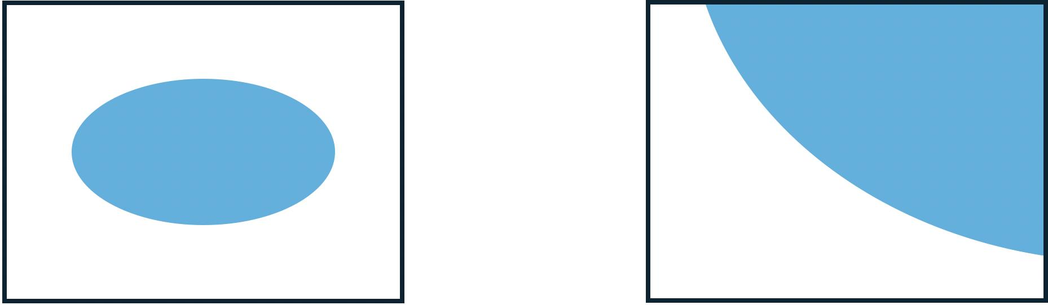

Definition
# Source: AI Source: Provided by: [Data Path: Persons Table -> ID Column: 1, Name_En Column: Motasem Essam] -> From: [ChatGPT] on [7/25/2026]
An Unbounded Region is a region of the plane that is not completely enclosed by a boundary and extends infinitely in at least one direction.
Unlike a bounded region, an unbounded region has no finite limit in one or more directions. Although it may have one or more boundary lines or curves, those boundaries do not form a closed enclosure.

Characteristics
# Source: AI Source: Provided by: [Data Path: Persons Table -> ID Column: 1, Name_En Column: Motasem Essam] -> From: [ChatGPT] on [7/25/2026]
An unbounded region:
- Extends infinitely in at least one direction.
- Is not completely enclosed by a closed boundary.
- Has infinite extent.
- Does not have a finite area.
- May be defined by one or more lines, rays, or curves.
- Contains infinitely many points.

Illustration

Half-Plane
# Source: AI Source: Provided by: [Data Path: Persons Table -> ID Column: 1, Name_En Column: Motasem Essam] -> From: [ChatGPT] on [7/25/2026]
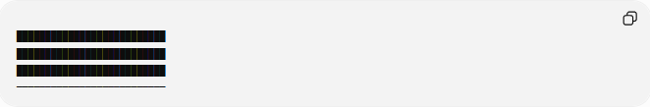
██████████████████████████
██████████████████████████
██████████████████████████
──────────────────────────
The line forms the boundary.
The shaded region extends infinitely upward, making it an unbounded region.

Exterior of a Circle
# Source: AI Source: Provided by: [Data Path: Persons Table -> ID Column: 1, Name_En Column: Motasem Essam] -> From: [ChatGPT] on [7/25/2026]
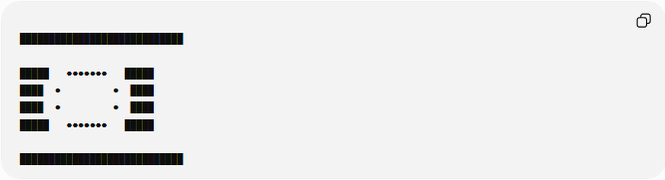
████████████████████████████

█████ ●●●●●●● █████
████ ● ● ████
████ ● ● ████
█████ ●●●●●●● █████

████████████████████████████
The shaded exterior extends infinitely in every outward direction.
The circle is the boundary.

Mathematical Representation
# Source: AI Source: Provided by: [Data Path: Persons Table -> ID Column: 1, Name_En Column: Motasem Essam] -> From: [ChatGPT] on [7/25/2026]
An unbounded region is often represented using inequalities.
Example 1
Above a line:
$$y>2$$
This region extends infinitely upward.

Example 2
Outside a circle:
$$x^{2}+y^{2}>r^{2}$$
This region extends infinitely away from the circle.

Examples
# Source: AI Source: Provided by: [Data Path: Persons Table -> ID Column: 1, Name_En Column: Motasem Essam] -> From: [ChatGPT] on [7/25/2026]
Example 1 – Half-Plane
A line divides the plane into two regions.
Each half-plane is an unbounded region.

████████████████
────────────────

Example 2 – Outside a Triangle
The region outside a triangle extends infinitely.

Example 3 – Outside a Polygon
The exterior of any polygon is an unbounded region.

Boundary of an Unbounded Region
# Source: AI Source: Provided by: [Data Path: Persons Table -> ID Column: 1, Name_En Column: Motasem Essam] -> From: [ChatGPT] on [7/25/2026]
An unbounded region may still have a boundary.
Examples:
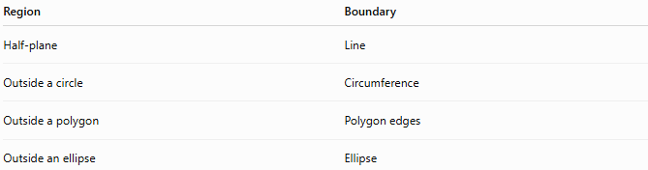
Region | Boundary
Half-plane | Line
Outside a circle | Circumference
Outside a polygon | Polygon edges
Outside an ellipse | Ellipse
The boundary separates the unbounded region from the bounded interior.

Area of an Unbounded Region
# Source: AI Source: Provided by: [Data Path: Persons Table -> ID Column: 1, Name_En Column: Motasem Essam] -> From: [ChatGPT] on [7/25/2026]
Since an unbounded region extends infinitely:
- It does not have a finite area.
- In many contexts, its area is considered infinite.

Real-World Examples
# Source: AI Source: Provided by: [Data Path: Persons Table -> ID Column: 1, Name_En Column: Motasem Essam] -> From: [ChatGPT] on [7/25/2026]
Unbounded regions include:
- The sky above the ground.
- The open sea beyond a coastline.
- Land outside a fenced property.
- Space surrounding a planet.
- The area beyond a city's boundary.
- The outside of a circular park.

Applications
# Source: AI Source: Provided by: [Data Path: Persons Table -> ID Column: 1, Name_En Column: Motasem Essam] -> From: [ChatGPT] on [7/25/2026]
Unbounded regions are used in:
- Plane Geometry
- Coordinate Geometry
- Analytic Geometry
- Topology
- Engineering
- Architecture
- Surveying
- GIS (Geographic Information Systems)
- Computer Graphics
- Computational Geometry

Advantages
# Source: AI Source: Provided by: [Data Path: Persons Table -> ID Column: 1, Name_En Column: Motasem Essam] -> From: [ChatGPT] on [7/25/2026]
Studying unbounded regions helps to:
- Analyze inequalities.
- Understand half-planes.
- Describe open spaces.
- Solve optimization problems.
- Model infinite domains.

Limitations
# Source: AI Source: Provided by: [Data Path: Persons Table -> ID Column: 1, Name_En Column: Motasem Essam] -> From: [ChatGPT] on [7/25/2026]
An unbounded region:
- Has no finite area.
- Cannot be completely enclosed.
- Extends indefinitely.
- May be more difficult to visualize than bounded regions.

Comparison with Other Region Types
# Source: AI Source: Provided by: [Data Path: Persons Table -> ID Column: 1, Name_En Column: Motasem Essam] -> From: [ChatGPT] on [7/25/2026]
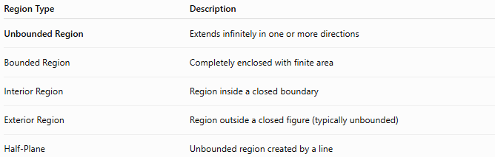
Region Type | Description
Unbounded Region | Extends infinitely in one or more directions
Bounded Region | Completely enclosed with finite area
Interior Region | Region inside a closed boundary
Exterior Region | Region outside a closed figure (typically unbounded)
Half-Plane | Unbounded region created by a line

Key Points
# Source: AI Source: Provided by: [Data Path: Persons Table -> ID Column: 1, Name_En Column: Motasem Essam] -> From: [ChatGPT] on [7/25/2026]
- An Unbounded Region extends infinitely.
- It is not completely enclosed by a boundary.
- It may still have one or more boundaries.
- Examples include:
  - Half-planes.
  - Outside of circles.
  - Outside of polygons.
- Its area is not finite.

Conclusion
# Source: AI Source: Provided by: [Data Path: Persons Table -> ID Column: 1, Name_En Column: Motasem Essam] -> From: [ChatGPT] on [7/25/2026]
An Unbounded Region is a portion of the plane that extends infinitely in at least one direction and is not fully enclosed by a closed boundary. Although it may be separated from other regions by lines or curves, it has no finite limits or finite area. Unbounded regions are fundamental in plane geometry, coordinate geometry, analytic geometry, topology, engineering, surveying, GIS, computational geometry, and computer graphics, where they are used to model open spaces, represent solution sets of inequalities, and describe regions extending without bound.

